

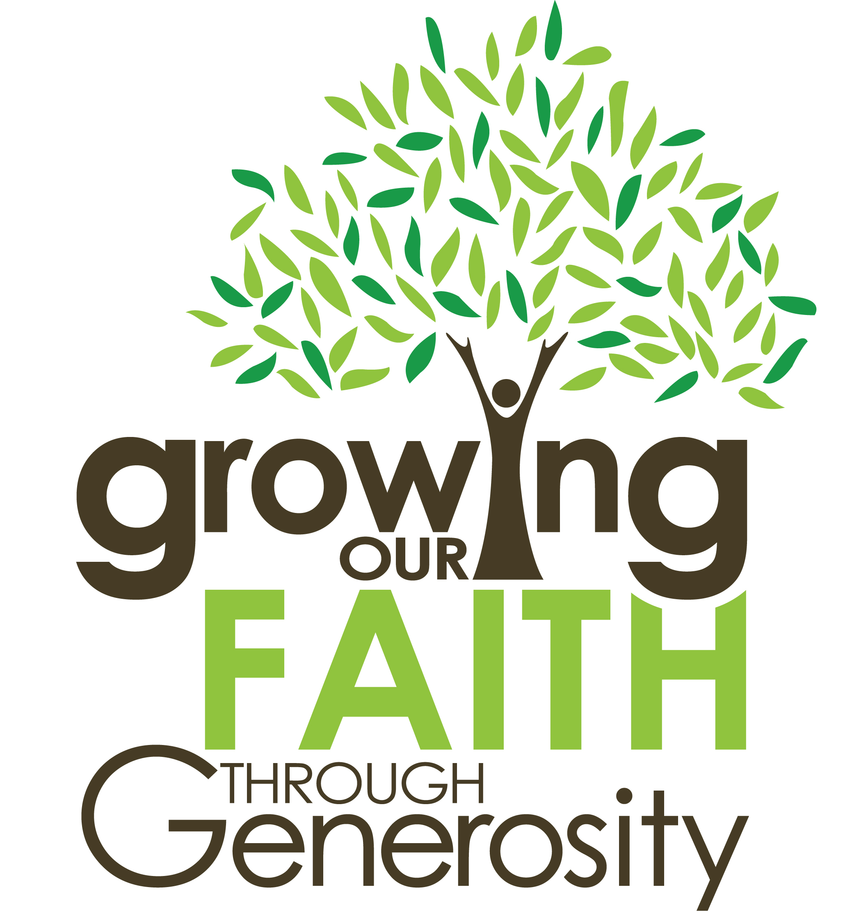



Reflections on Giving

Our privilege together

Friends,

Being able to leading the amazingly talented, generous & faithful people that go to make up our church is one of the greatest privileges of my life. God has given us great richness in each other and a great calling to serve not only one another but also the wider parish, town and world. The joyful message of hope we embody is a wonderful truth to know and a great gift to share with a world so desperately in need. Our church’s commitment to be a ‘Blessing to our Local Community’ is something we want to get better at.

In order to sustain the wonderful work that God is doing amongst us I must ask you to think about the way you are able to support this church. We have great opportunities before us and I believe God is wanting to bless us. But, to take hold of all that we hope to achieve we need to pool all the resources we have, not least our finances.

Be encouraged by what we are doing, be challenged by what we could do and then join in!

Yours in Christ,



As a Church we want to say THANK YOU to those of you who support us. Without your wonderful generosity we would not be able to achieve the great things that God is doing here at St Andrew’s. Whether you increase, decrease or continue with your current level of giving I would like you to know how grateful we are for your financial commitment and faithfulness to us throughout this last year.

Secondly, I write to challenge those not yet financially committed. Maybe you’ve recently come to faith, or just joined us; maybe you’ve never before thought about the importance of giving to the church. I urge you to consider this now.

Please take some time, to think through your giving for the year ahead. Part of this booklet teaches a little of what the Bible says about our attitude and our approach to money and giving. Please use it to help you prayerfully consider what you might give.

Thank you again for your time and attention as you engage with this vital issue of Christian stewardship and giving.

Please be generous as God has been generous to you.


Stewardship … what we do after we say we believe

Stewardship is founded on God's word, not on the fundraising or other needs of the church. Stewardship is rooted in the premise that all that we have and all that we are comes from God and, as a way to thank Him for all His blessings, we return a portion of the time, talent and treasure allotted to us.

Good stewards will volunteer their TIME, TALENT and TREASURE to community agencies as well as to the church. Clearly, stewardship is not a fundraising ploy; it is a way of life based on deeply rooted spiritual principles.

Bible teaching on Time

Teach us to consider our mortality,
so that we might live wisely. Psalm 90:12

There are many inequities in the world, but one thing we all have in common is the same amount of time each day. God has allotted twenty-four hours to each one of us. We tend to think and act as though God has short changed us when it comes to time. The feeling is that there simply aren’t enough hours in a day. Life with all its demands is far too busy.

To be a good steward of time we need to have a grasp of time in the sense of understanding the great events of God in history, past, present, and future. The goal of stewarding our time well is not to get Christians busier. It is not busier lives that we need. What is needed instead is a better use of the time we have.

Ultimately, we must also ask and respond to the issue of just why we are here on earth for. We are here as ambassadors of Christ called to a world-wide mission of making disciples of all nations starting in Jerusalem (home base) and reaching out to the uttermost part of the earth (Matt. 28:19-20; Acts 1:8). We are here to represent the Saviour, to glorify God, and enjoy Him forever.

We need to do this in our personal lives and also by volunteering in our shared life together – bringing what we have into the service of others.

Bible teaching on Talent

Now there are varieties of gifts, but the same Spirit; and there are varieties of service, but the same Lord; and there are varieties of activities, but it is the same God who empowers them all in everyone. To each is given the manifestation of the Spirit for the common good.
1 Corinthians 12:4-7

Every Christian possesses both natural talents and spiritual gifts. Our natural abilities come to us at physical birth and are developed through life. Our spiritual gifts are imparted by the Holy Spirit, enabling us to minister to others in behalf of Christ.

God has equipped you by His Spirit to minister in a way as unique as your fingerprints. In God’s family, everyone is considered “gifted.” Regardless of your personality, your IQ, or how high or low you rank on the social strata, you have spiritual gifts. And the body of Christ needs you—just as God designed.

We have many volunteers at St Andrew’s CC in dozens of different roles … some are more practical ... others are more ‘spiritual’. Some are obvious to others and some are more behind the scenes…. They are ALL important and we need lots more people to join us in order to achieve all that we believe God has called us to,

Volunteering at Church is a great way to serve God and Get to know others. Please speak to Ruth if you’d like to find out where you might fit into our church family team.

Bible teaching on Treasure

What the Bible says
about Treasure?

The Bible has a great deal to say about money, our attitude to it and what we do with it.

“Each of you must give as you have made up your mind, not reluctantly or under compulsion, for God loves a cheerful giver. And God is able to provide you with every blessing in abundance, so that by always having enough of everything, you may share abundantly in every good work.”
2 Corinthians 9:7-8 (NRSV)

Why give?

In response to God’s grace
God has shown his great love for sinful and unworthy people like us in the life, death and resurrection of the Lord Jesus Christ. Having received such undeserved generosity we should be motivated to give generously in response. We are to be like God - not reluctant givers, but wanting to give generously from all that he has given us.

In recognition of God’s gifts
God wants us to be generous – not just with our money but with our time, energy, skills, homes and possessions. If we have received God’s abundant grace then we all have something to give. Sometimes these other things are harder to give than money.

In reaction to needs and priorities
The apostle Paul encourages the Corinthian Christians to give generously to a collection for other Christians in great poverty. God’s priorities are that his people should come first in our giving: those who teach the word of God (1 Tim 5:17), those in need in our church (James 1:27, 1 Tim 5:8) and those in need in other churches (2 Cor 8-9). The needs are therefore both the local work of the parish and further afield in the wider church

To be freed from greed & the love of money

The only cure for greed is to give.

How to give?

Abundantly
The apostle Paul stresses the abundant nature of God’s giving towards us so that we may give abundantly in response. God is able to make all grace abound to you, so that in all things at all times, having all that you need, you will abound in every good
work. The Old Testament commanded a tithe (10% of income). The New Testament is far more radical: we are to be generous givers of all we have.
Some will give far more than 10% of their income, others less.

Thoughtfully
Each of you must give as you have made up your mind. We need to think carefully about what we have been given, what our responsibilities are and how we can give money in the most effective way.

Joyfully
God loves a cheerful giver. It’s easy to give for the wrong reasons - to relieve our guilt, to avoid other avenues of Christian service, to be seen to be generous by others. The apostle Paul tells us that God loves a joyful and big-hearted response to all that he has lavished on us.

How much should I give?

The amount we give to our local church is a decision to be made honestly between us and God. There is clearly no right answer and many church family members will be giving both to the church and to other organisations. However, three practical suggestions might be useful as you prayerfully consider:

• Even if you are on a restricted income, perhaps as a pensioner or student, it is still good to develop a habit of giving - perhaps a Standing Order of a small amount each month. Standing Orders provide discipline and help us to prioritise giving, even when our budget is limited.

• Those with higher earnings might like to give at a level to fund specific projects or church resources.

• The Old Testament suggested that the Tithe (10%) was a place to start – yes, start – and Jesus was often even more challenging. The Church of England suggests that if you take that as a basis then allocate half of your total giving through your church. The good thing about this figure is that it is both a proportion of income most people have found they can manage to give (many give more) and a way to ensure you give adequately as your income increases. The Methodist Church emphasises generosity towards God.


If you feel able to give 5% or 10% of your income (after tax) to the church, this table will help you to work out how much to give each week or month.
Your Annual Income from working, pensions or investments | £4,000 | £15,000 | £20,000 | £40,000 | £50,000
Annual Take Home Pay after paying tax & NI | £4,000 | £12,732 | £16,132 | £29,732 | £35,779
If you give 5% | £200 | £637 | £807 | £1,487 | £1,789
This would mean you give each week | £3.85 | £12.24 | £15.51 | £28.59 | £34.40
Or each month should be | £16.67 | £53.05 | £67.22 | £123.88 | £149.08
If you give 10% | £400.00 | £1,273.20 | £1,613.20 | £2,973.20 | £3,577.90
This would mean you give each week | £7.69 | £24.48 | £31.02 | £57.18 | £68.81
Or each month should be | £33.33 | £106.10 | £134.43 | £247.77 | £298.16

This table is for illustration only. It does not account for any benefits or other kinds of income. It is designed to help as a guide and not to be directive – the amounts maybe too much or too little for you to give – only you and God can decide what the right amount is for you to cheerfully contribute.

What is my level of giving?
The ‘tip’ level – small change for God.
The ‘entertainment’ level – pay when I go
The ‘emotional’ level – give when I feel like it
The ‘good intentional’ level – I will do better when I’ve got more to spare and it won’t interfere with anything else
The ‘Christian’ level – I will give as I have been given, systematically and sacrificially in proportion to my ability, gladly and ungrudgingly

The Small Print

Conditions for Gift Aid

Making donations
• There is no minimum amount or minimum term for Gift Aid.
• Donations may be made by Standing Order, cheque, direct bank transfer or cash.
• To qualify for Gift Aid, you must pay an amount of UK Income Tax or Capital Gains Tax at least equal to the tax the church reclaims on your donations.

Changes in your situation
• You are responsible for informing the Gift Aid Officer if your tax situation changes for any given tax year in which you have authorised the church to make Gift Aid claims. Please do get in contact even if this relates to years in the past for which you overlooked or were unaware of this requirement – the church can adjust previous claims if necessary.
• You can cancel your declaration at any time by notifying the church treasurer.
Reclaiming tax
• The church will reclaim the basic rate tax you have paid on your donations when we have received your signed Gift Aid Declaration.
• If you pay tax at a higher rate, you can claim further tax relief when submitting your annual tax return.

Data protection
In completing and submitting the Gift Aid Declaration and/or Standing Order form, you agree that the parish may collect, store and use any personal information you may be providing for the purposes of administering your giving and complying with any requests for information from HMRC and for the purpose of providing you with information about our current and future programme of activities.

Acknowledgements to the Diocese of Wakefield, Bradford and the Stewardship Team of the Archbishop’s Council for reproduced stewardship material in this booklet.

GIFT AID DECLARATION
St Andrew’s Community Church Council

If you are a taxpayer and would like the Church to reclaim gift aid on your gift (which increases your gift to us) please contact:
treasurer@staccd.org.uk
And ask for a Gift Aid declaration form. Or ask for the treasurer when next attend a service.

Thank you.

St Andrew’s Community Church Office, Pentland Road, Dronfield Woodhouse S18 8ZQ
Please notify St Andrew’s CC Treasurer if you:-
* Want to cancel this declaration
* Change your name or home address
* No longer pay sufficient tax on your income and/or capital gains
If you pay Income Tax at the higher or additional rate and want to receive the additional tax
Relief due to you, you must include all your Gift Aid donations on your Self Assessment tax return or ask HM Revenue and Customs to adjust your tax code.

STANDING ORDER
St Andrew’s Community Church Council

To the Manager ________________________ Bank

Address _________________________________

_________________________________

Please pay to the St Andrew’s Community Church a/c 06940006 Santander Sort Code 09.01.56

The sum of £ _____ (_______________________) on the ___________
day of _________________ and on the same day each succeeding month/year until further notice and debit my account with each payment when made.

Account number _______________ Sorting Code ______________

Name [in block letters]: ____________________________________

Address: ________________________________
________________________________ Postcode __________

Tel: ______________________

Date: _________________ Signature: __________________

This instruction cancels any previous order in favour of the beneficiary.

Please return this form to St Andrew’s Community Church, Treasurer, via Church office, Pentland Road, Dronfield Woodhouse S18 8ZQ or hand it in to your own bank.
Thank you.



St Andrew’s Community Church,
Pentland Road,
Dronfield,
Derbyshire,
S18 8ZQ.

Tel: 01246 416893
Web: www.staccd.org.uk

